**Activity 7.2 - Walkthrough a Subnetted IPv4 Addressing Scheme (Not assessed)**

**Topology**

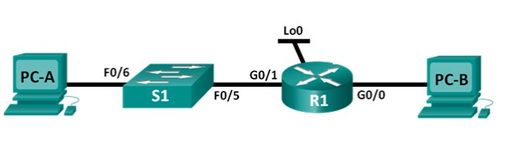

**Addressing Table**



|  |  |  |  |  |
| --- | --- | --- | --- | --- |
| **Device** | **Interface** | **IP Address** | **Subnet Mask** | **Default Gateway** |
| R1 | G0/0 | 192.168.0.65 | 255.255.255.192 | N/A |
|  | G0/1 | 192.168.0.1 | 255.255.255.192 | N/A |
|  | Lo0 | 192.168.0129 | 255.255.255.192 | N/A |
| S1 | VLAN 1 | N/A | N/A | N/A |
| PC-A | NIC | 192.168.0.2 | 255.255.255.192 | 192.168.0.1 |
| PC-B | NIC | 192.168.0.66 | 255.255.255.192 | 192.168.0.65 |

**Objectives**

**Part 1: Walkthrough a Network Subnetting Scheme**

**Step 1: Create a subnetting scheme that meets the required number of subnets and required number of host addresses.**

In this scenario, you are a network administrator for a small subdivision within a larger company. You must create multiple subnets out of the 192.168.0.0/24 network address space to meet the following requirements:

* The first subnet is the employee network. You need a minimum of 52 host IP addresses.
* The second subnet is the administration network. You need a minimum of 19 IP addresses.
* The third subnet is reserved as a virtual network on virtual router interface loopback 0. This virtual router interface simulates a LAN attached to R1.

**Note**: Variable length subnet masks will not be used. All of the device subnet masks will be the same length.

Answer the following questions to help create a subnetting scheme that meets the stated network requirements:

* 1. How many host addresses are needed in the largest required subnet? __________52_________

. All rights reserved. This document is Cisco Public.

* 1. What is the minimum number of subnets required? ___3 (two company, one loopback)____
  2. The network that you are tasked to subnet is 192.168.0.0/24. What is the /24 subnet mask in binary?

_______________________11111111 . 11111111 . 11111111 . 00000000___________________

* 1. The subnet mask is made up of two portions, the network portion, and the host portion. This is represented in the binary by the ones and the zeros in the subnet mask.

In the network mask, what do the ones represent? _______Network part_____________

In the network mask, what do the zeros represent? ______Host part__________________

* 1. To subnet a network, bits from the host portion of the original network mask are changed into subnet bits. The number of subnet bits defines the number of subnets. Given each of the possible subnet masks depicted in the following binary format, how many subnets and how many hosts are created in each example?

**Hint**: Remember that the number of host bits (to the power of 2) defines the number of hosts per subnet (minus 2), and the number of subnet bits (to the power of two) defines the number of subnets. The subnet bits (depicted in bold type face) are the bits that have been borrowed beyond the original network mask of /24. The /24 is the slash prefix notation and corresponds to a dotted decimal mask of 255.255.255.0.

# (/25) 11111111.11111111.11111111.**1**0000000

Dotted decimal subnet mask equivalent: ________________________________ 255.255.255.128

Number of subnets? ___2_____________, Number of hosts? _____126___________

Two subnets (21) and 128 (27) – 2 = 126 hosts per subnet

# (/26) 11111111.11111111.11111111.**11**000000

Dotted decimal subnet mask equivalent: ________________________________ 255.255.255.192

Number of subnets? ________4________, Number of hosts? _____62___________

Four subnets (22) and 64 (26) – 2 = 62 hosts per subnet

# (/27) 11111111.11111111.11111111.**111**00000

Dotted decimal subnet mask equivalent: ________________________________

255.255.255.224

Number of subnets? ________8________ Number of hosts? _____30___________

Eight subnets (23) and 32 (25) – 2 = 30 hosts per subnet

# (/28) 11111111.11111111.11111111.**1111**0000

Dotted decimal subnet mask equivalent: ________________________________

255.255.255.240

Number of subnets? _________16_______ Number of hosts? ______14___________

Sixteen subnets (24) and 16 (24) – 2 = 14 hosts per subnet

# (/29) 11111111.11111111.11111111.**11111**000

Dotted decimal subnet mask equivalent: ________________________________

255.255.255.248

Number of subnets? _________32_______ Number of hosts? ______6___________

Thirty two subnets (25) and 8 (23) – 2 = 6 hosts per subnet

# (/30) 11111111.11111111.11111111.**111111**00

Dotted decimal subnet mask equivalent: ________________________________

255.255.255.252

Number of subnets? _____64___________ Number of hosts? ___2______________

Sixty four subnets (26) and 4 hosts (22) – 2 = 2 hosts per subnet

6) How many network bits do you need to satisfy the number of networks required?

_There are 3 networks needed. So we need 2 network bits because 2^2 = 4 7) How many host bits do you need to satisfy the largest network?

The largest network has 52 hosts. So we need 6 host bits because 2^6 = 64

1. Considering your answers, which subnet masks meet the required number of minimum host addresses?

|  |  |
| --- | --- |
| We need a minimum of 62 hosts per network. That means a subnet mask of either /25 (126 hosts), | |
| or /26 (62 hosts would work | . |

But, we also need 3 networks and the /25 network will only give us 2 subnets.

|  |  |
| --- | --- |
| The /25 network would not work in this case and we need a /26 network – see working in next | |
| question | . |

1. Considering your answers, which subnet masks meets the minimum number of subnets required?

|  |  |
| --- | --- |
| We need 3 networks. /26 = 4 networks, /27 = 8 networks, /28 = 16 networks, /29 = 32 networks, /30 = | |
| 64 networks | . |

1. Considering your answers, which subnet mask meets both the required minimum number of hosts and the minimum number of subnets required?

|  |  |
| --- | --- |
| /26 network will give you four subnets, which is greater than the minimum of 3 required, and 62 hosts | |
| per subnet, which is greater than the 52 hosts required for the first subnet. |  |

The subnet mask is: 11111111 . 11111111 . 11111111 . 11000000

1. When you have determined which subnet mask meets all of the stated network requirements, you will derive each of the subnets starting from the original network address. List the subnets from first to last below. Remember that the first subnet is 192.168.0.0 with the newly acquired subnet mask.

|  |  |  |
| --- | --- | --- |
| Subnet address | Prefix | Subnet mask |
| 192.168.0.0 | /26 | 255.255.255.192 |
| 192.168.0.64 | /26 | 255.255.255.192 |
| 192.168.0.128 | /26 | 255.255.255.192 |
| 192.168.0.192 | /26 | 255.255.255.192 |

1. Complete the diagram showing where the host IP addresses will be applied.

On the following lines provided, fill in the IP addresses and subnets masks in slash prefix notation.

On the router:

Gigabit Ethernet 0/1 is the first subnet. Use the first available address on the subnet for this interface.

Gigabit Ethernet 0/0 is the second subnet. Use the first available address on the subnet for this interface.

loopback 0 is the third subnet. Use the first available address on the subnet for this interface.

On PC-A:

Use the second available address on the network.

On PC-B:

Use the second available address on the network.

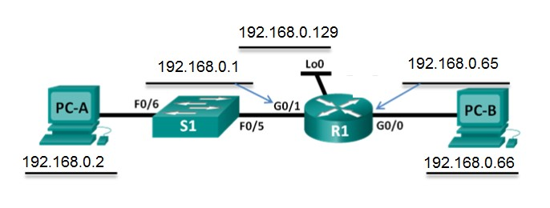

13) Also enter this information into the Addressing Table:

|  |  |  |  |  |
| --- | --- | --- | --- | --- |
| **Device** | **Interface** | **IP Address** | **Subnet Mask** | **Default Gateway** |
| R1 | G0/0 | 192.168.0.65 | 255.255.255.192 | N/A |
|  | G0/1 | 192.168.0.1 | 255.255.255.192 | N/A |
|  | Lo0 | 192.168.0.129 | 255.255.255.192 | N/A |
| S1 | VLAN 1 | N/A | N/A | N/A |
| PC-A | NIC | 192.168.0.2 | 255.255.255.192 | 192.168.0.1 |
| PC-B | NIC | 192.168.0.66 | 255.255.255.192 | 192.168.0.65 |

**Testing (not assessed and not to be submitted on the course website):**

You may wish to create and test this network in Packet Tracer.

**NOTE:** Any Packet Tracer files that you create for this must not be submitted as part of the assessment.



